Troop 349
Orienteering Campout
Prince William Forest
Triangle, VA
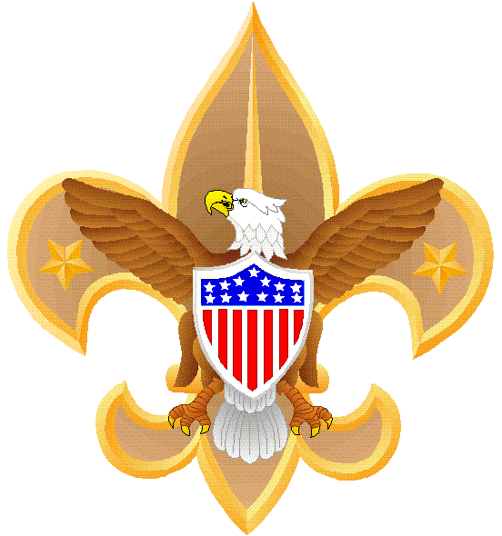
Mar 9-11, 2018
Deadline for permission slip & payment: Tues, Mar 6

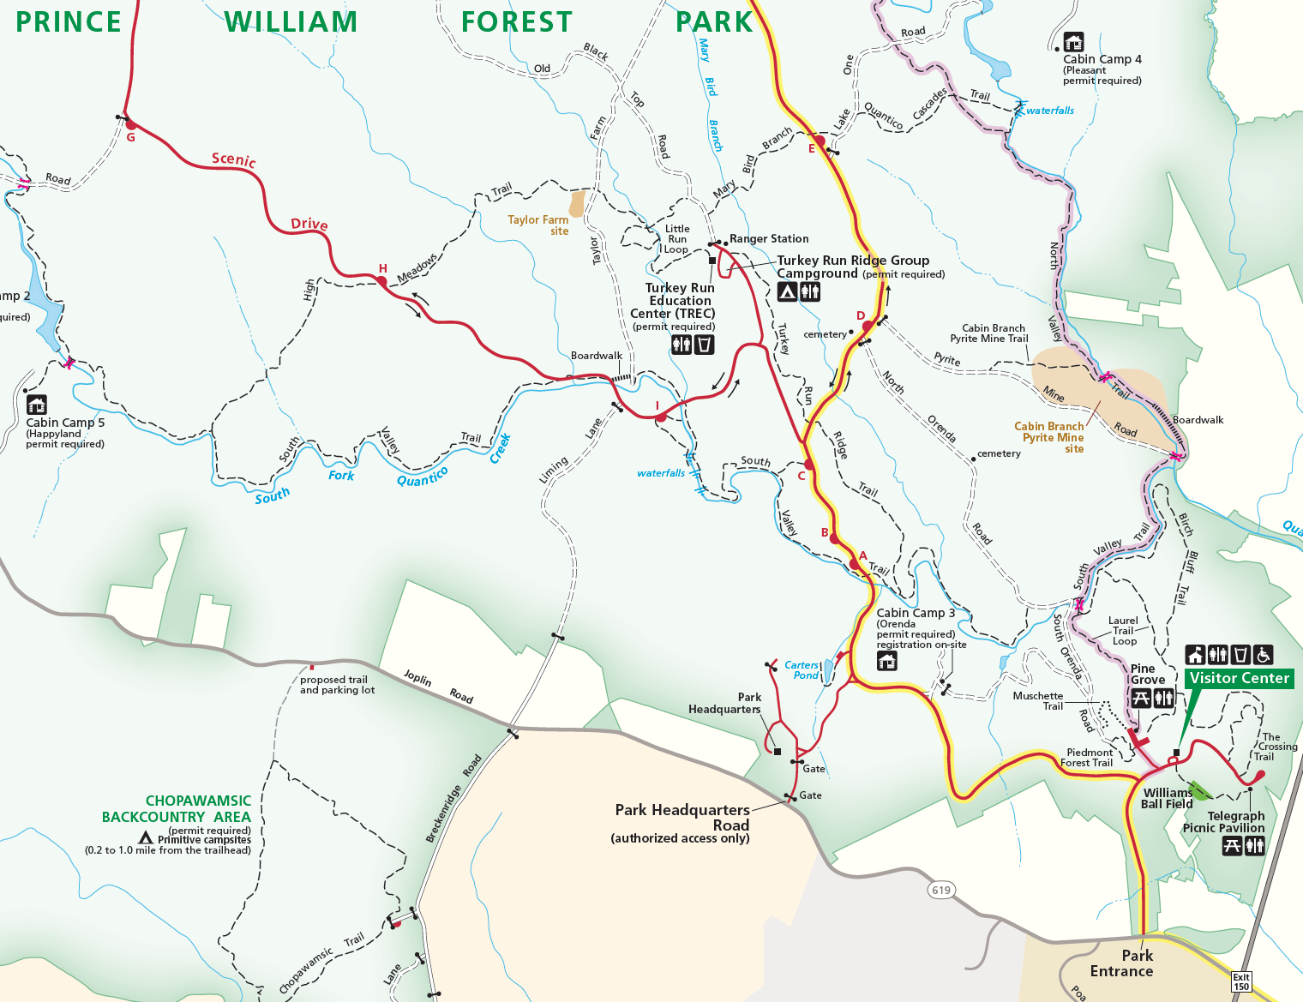
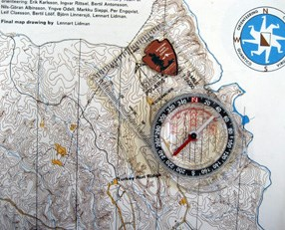
This will be a “car camping” campout with water and bathrooms available. The focus will learn the use of a map and compass to navigate (orienteering) around the Park. There are several pre-set orienteering courses. We will take advantage of training via the Park Ranger and then explore the Park courses using our map and compass.
There are at least 14 different courses to choose from in 2018. We also have the option of hiking on one of the Parks several trails including the South Valley Trail; a 8.7 mile loop allowing a thorough exploration of the Park (https://www.nps.gov/prwi/planyourvisit/hiking.htm).
Weather outlook (preliminary): Assume 50s during the day with chance of rain, 30s at night. Bring rain gear and layers so you can add or take off during the day.

Other items to note:
- There is a $7 per vehicle park entrance fee (not waved for group camping)
- Check-in at the visitor center before proceeding to the campground
- Firewood may or may not be provided in the campground; If you bring your own firewood, it must be USDA certified "bug-free" firewood
- Having your own compass is preferred but not required
- Bring a day pack, water bottle, pen & notebook/paper and comfortable hiking shoes
Friday, Mar 9
Time | Event | POC | Remarks
1630 | Arrive American Legion | SPL, QM | Class A uniform for travel
1715 | Depart | SM
Approx 1815 | Arrive Prince William Forest |  | Sunset 18:10 PM, 50% Moon
1815 | Camp site set-up | SPL, QM | Class B uniform
1900 - 2030 | Supper and Clean Up | By Patrol
2030 - 2130 | Camp Fire | SM | Informal meeting & snack
2130 | End of Day / Next Day Prep | SPL & SM | Hot wash & planning
2200 | Lights out

Saturday, Mar 10
Time | Event | POC | Remarks
0700 | Wake-up | SM & SPL | Sunrise 06:28 AM
0700-0930 | Breakfast and clean-up | By Patrol
0930-1000 | Transition to Orienteering Training | By Patrol | Meet up with Ranger Chris Alford at Turkey Run Education Center Parking Area
1000-1130 | Orienteering Training and testing skills on short course | SPL & SM | Class B uniform. At Ranger’s Station
1130-1330 | Lunch and clean-up | By Patrol | Return from training to campsite for meal prep, etc
1330-1730 | Orienteering Course/ Hiking | SPL & SM | All
1700-1900 | Supper and Clean Up | By Patrols | Sunset 18:11 PM, Waining Cresent Moon 41%
1900-2100 | Troop Campfire | SPL | Informal meeting & snack
2100 – 2200 | End of Day / Next Day Prep |  | Hot wash & planning
2200 | Lights out | SPL & SM

Sunday, Mar 11
Time | Event | POC | Remarks
0700 | Wake-up | SM & SPL | Sunrise 07:26 AM (NOTE: Start Daylight Savings Time – “Spring Forward”)
0700-0830 | Breakfast, clean-up | All
0830-1000 | Break camp | SPL & PLs
1000 | Depart | All
1130 | Arrive at American Legion
24/7 Emergency Room:
Sentara N. Virginia Medical Center Emergency Room
23000 Opitz Blvd
Woodbridge, VA 22191
Phone: 703.523.1000
Directions:
From the American Legion Post 130, 400 N Oak Str, Falls Church, VA 22046
Head south on N Oak Str
Turn right onto W Broad Str
Continue onto Leesburg Pike
Merge onto I-66 W

Take Exist 64 for 495 S

Merge onto 495 and follow for approx. 8 miles to Exist 57A towards VA-644

Follow signs for 95 S. Stay on 95 S for approx. 20 miles

Look for and take Exit 150B for VA-619 W. After exiting, turn right on Park Entrance Rd
After check-in, follow signs back to the Turkey Run Ridge Group Campsite, SITE B (reservation # 2-39516294)

IIf there is cell phone coverage, Contact Andrew Mitchell (571.277.7905)

Until our next adventure
BSA TROOP 349, FALLS CHURCH, VA
PERMISSION SLIP

Event: Orienteering Campout

Location: Prince William Forest

Date: Mar 9 - 11, 2018

As the parent or legal guardian of: _____________

I give my permission for him to participate in this outing with Troop 349.

I will provide transportation. Out Back Both
Including driver, my vehicle holds _______ people.

Name(s) of Parent(s) planning to attend: ____________ Parent cell #:

My Scout understands: All travel is in Class A uniform
No electronics permitted (iPod, MP3, cell phone, etc)

Funds attached: Free due to great past fund raising efforts

I give permission to the uniformed adults of Troop 349 to render first aid. In the event of emergency, I give permission to the physician selected by the adult leader-in-charge, to hospitalize, order anesthesia, order injection, or secure other medical treatment, as s/he determines to be appropriate. I further agree to hold Troop 349 and its uniformed adults blameless for any mishaps that may occur during this outing, except for clear acts of negligence or non-adherence to BSA policies and guidelines.

In case of emergency, I can be reached by phone at: or:

If I cannot be reached, contact: Phone:

Medical Insurance company: Policy number:

My son: Has the following medical condition(s) that uniformed adults must be aware of:
.
Has no medical condition.
Requires the following medication(s) that uniformed adults must supervise and assist in administering (also provide time & quantity):
.
Takes no medication

Signed: _____________________________ Date:
(Parent or Guardian)

DUE BY MAR 6, 2018.

Cold Weather Packing Checklist

Note: This list is in addition to clothes worn to campout.
Wear your Class A Scout uniform for travel.

Remember: “Cotton Kills” & “Always pack for one season colder than now.”

Sleeping Gear:
____ Backpack or duffle bag (lined w/plastic bag to keep contents dry)
____ Sleeping bag
____ Pillow Case (to be stuffed with your down jacket or clothing)

Clothes:
____ Winter coat or vest
____ Warm cap
____ Gloves or mittens
____ Sunglasses
____ Pants
____ 2 Long sleeve shirts
____ Class B shirt
____ Class B fleece or vest
____ 2 Underwear
____ Long underwear, top & bottom
____ 2 pair wool or acrylic socks
____ Hiking boots or walking shoes (no open-toe sandals)

Safety, Kitchen & Toiletry, Miscellaneous:
____ Personal 1st Aid Kit (BSA Handbook p. 289)
____ Water bottle, filled
____ Pen/pencil & pocket-sized notepad
____ Scout Handbook
____ Book for reading
____ Whistle on neck lanyard
____ Compass with a base plate
____ Toiletry kit (hand soap, toothbrush, toothpaste, floss, comb, small towel)
____ Toilet paper (half a roll in a Zip-Lock bag)
____ Flashlight/head lamp & extra batteries (keep easily accessible in backpack)
____ Two garbage bags (for storage of items; for trash cleanup at end of campout)
____ Camera

