<<< FOR IMMEDIATE RELEASE >>>

CONTACT:
Your Name
Your Title in the troop, Troop 349
Your Phone 000-000-0000
info@troop349.us
www.troop349.us

Falls Church City Troop 349… INCLUDE YOUR HEADLINE HERE!
Falls Church, Virginia, 00/00/0000 –

Insert your copy here; try use action words and descriptions that are brief and helpful to the reader to understand the activity being written about don’t be too verbose. Use a quote from someone in authority and close with an upbeat assessment of the activity. Try to keep your release to one page with photos on the next page, if you can include a couple of photos make sure they have captions with them. Use the following boilerplate for the troop at the end.

Wherever there is red copy please insert your information and format the test as black.

Make sure you forward a copy to the web master to include in the site.

ABOUT TROOP 349: The Troop is open to any boy between the ages of 12 and 17, who has graduated from the fourth grade, and/or has received his arrow of light award. Boys desiring to join the troop are welcome at any time to attend a meeting and present themselves to the Scout Master for admission. Troop 349 meets every Tuesday evening at 7 PM between September and June at the American Legion Hall on Oak St. The troop web site contains more information about joining and what Boy Scouts is all about. Go to www.troop349.us and click on downloads to view the scout handbook and primer.

— MORE ON NEXT PAGE —

or

— END —
-
Members of Troop 349 with some of the food donated to Scouting for Food 2010, L to R: Michael Keays, James Pala, SPL Truman Custer, Matthew Valley, Jack Ulses, Ian Griffin, Preston Custer, Tony Ulses. Front row L to R: Seamus Murphy, Timothy Gilmour, and Michael Andrew Keays
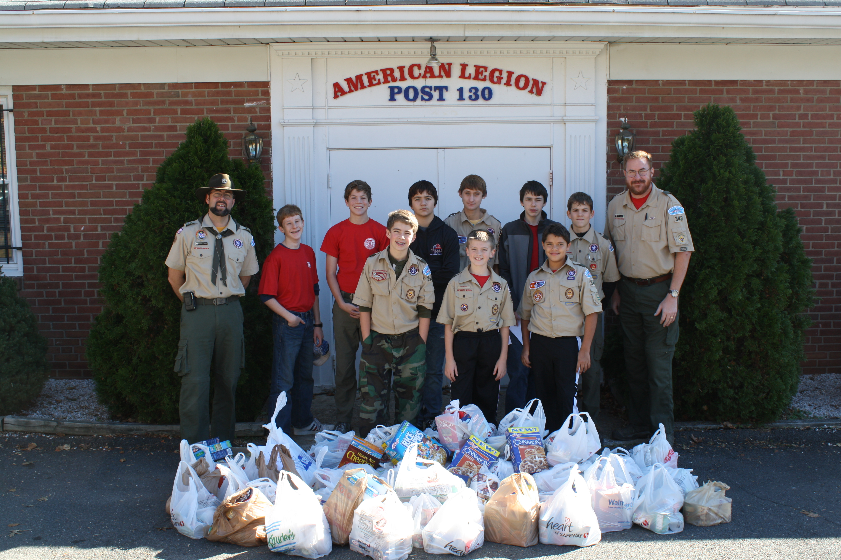
-END-

